**Practical No. 2: Write simple Python program to display message on screen**

**Name: Suyog Chavan**

**Roll No: 71 Tyco**

1. **Title:**

Write simple Python program to display message on screen

1. **Course Outcome(s)**

• Display message on screen using Python script on IDE

1. **Practical Outcome (PrOs)**
2. Write simple Python program to display message on screen
3. **Practical Related Questions:**
4. List different modes of Programming in Python

🡪 There are two modes of python programming

* interactive mode
* script mode

1. Describe procedure to execute program using Interactive mode.

🡪 For working with interactive mode open python IDLE in interactive mode. Type your code/statement into prompt (after >>>) and press enters you will get output.

1. State the steps involved in executing the program using script mode.

🡪 go to file -> create new file or press ctrl+N -> Write your script/code ->execute your script/code using F5 or Run button

1. State the procedure to make file executable.

🡪 Procedure to make file executable

1. Install python and set system variable.
2. Write code and save it
3. Install the Pypinstaller package
4. Create the Executable using Pyinstaller
   * 1. Go to CMD and type cd followed by the location where your Python script is stored
     2. Use the following templet to create the executable:

Pyinstaller –onefile pythonscriptName.py

* + 1. Press Enter

1. Run the executable
   * 1. You will find .exe file in dist folder
     2. Simply double click to run it.
2. **Exercise**
3. **Write a Python program to display your name using Interactive Mode**

* 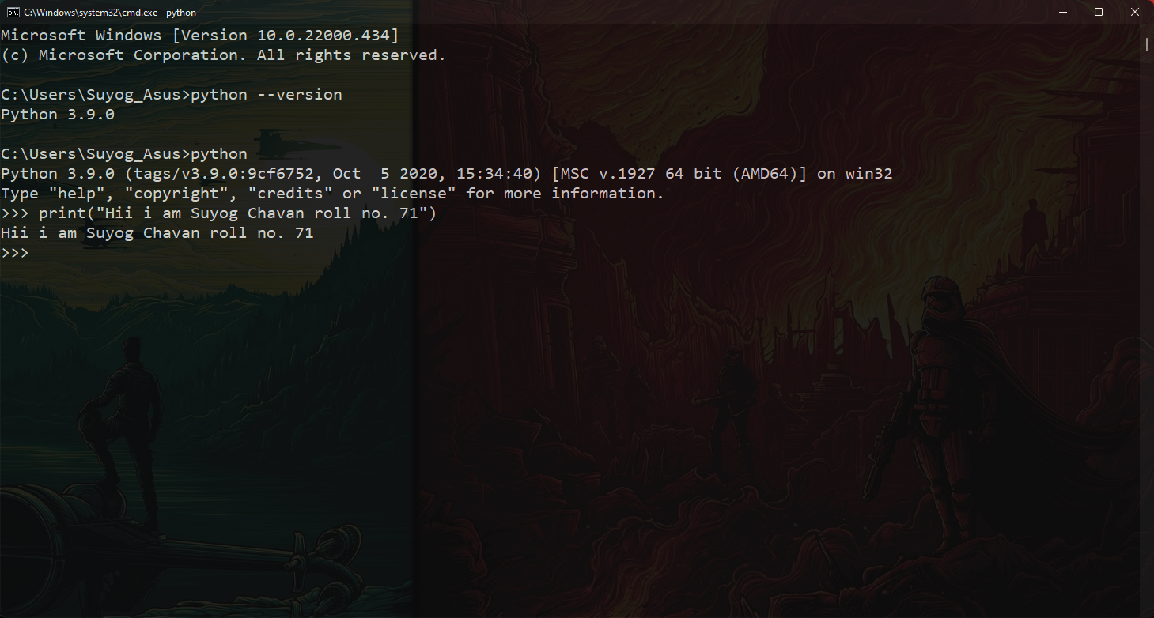

1. **Write a Python program to display “MSBTE” using Script mode**

* 